Tutorial 6

(Heuristic Search Algorithms)

Problem 1
Consider the following graph. Find the most cost-effective path from initial state S to reach the goal state I using Best First Search Algorithm.
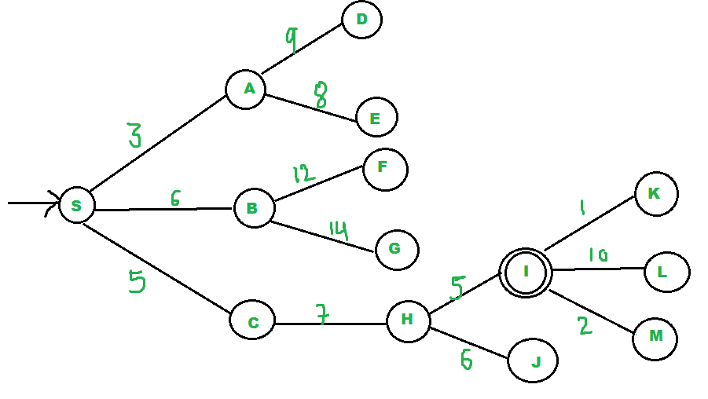

Problem 2
Given an initial state of a 8-puzzle problem and final state to be reached.

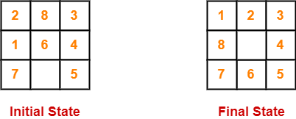

Find the most cost-effective path to reach the final state from initial state using A* Algorithm.
Consider g(n) = Depth of node and h(n) = Number of misplaced tiles.

Problem 3
Consider the following graph. Find the most cost-effective path to reach from start state A to final state J using A* Algorithm. The numbers written on edges / nodes represent the distance between the nodes / the heuristic value, respectively.

